|  |
| --- |
| Crafty Cuts Laser |
| User Documentation |
| Version 1.2 |

|  |
| --- |
| Jack Irving, Fiona Huang and Nasser Al-Oqayli  1-31-2016 |

Contents

Introduction: 3

Key Terms, Acronyms and Abbreviations 3

1. Overview: 4

The intended audience 4

The database 4

Accessing the system 5

2. Navigating the system 7

a. Main navigation 7

3. System Functionality 8

a. The administrator functionalities 8

b. The customer functionalities 9

4. Administrator’s Functionalities 11

View Profile 11

Change Password 11

Manage Customers 13

View All Customers 13

View Customer 14

Edit Customer 15

Delete Customer 16

Download PDF 16

Register new Customer 17

Manage Page Contents 19

Edit Page Contents 19

Edit Slider Images 21

View slider images 21

Add slider images 22

Manage Products 23

View all product 23

Create new product 24

Manage product colours 27

Manage product materials 28

View all materials 29

Add new material 29

Delete material 30

Manage sizes 30

View all sizes 30

Add size 31

Manage finishes 31

View all finishes 32

Add new finishes 32

Manage product categories 32

View all categories 32

Add new category 33

Manage Shipping Costs 33

Manage Sales 34

View all unpaid orders 36

View all paid orders 36

View all completed sales 37

5. Customer Functions 37

Registration 37

View/Edit Profile 39

Customer Change Password 40

Customer Contact the Admin 42

Customer View Company’s Details 43

Customer View Products 43

Customer Filter Categories 45

Customer Purchase Order 46

6. Password Recovery 50

Webmail 52

Login and Logging out 55

Backups and restores 56

# Introduction:

The main goal of this document is to guide the users of Crafty Cuts Laser system through its functions. It is important to understand how the functionalities are works, so that it reduces the chance of misuse or crash the system. In this report, all the required knowledge of Crafty Cuts Laser system will be covered including users, database, technology and system functionalities for both administrators and customers.

# Key Terms, Acronyms and Abbreviations

CakePHP: an open source PHP web development framework. It allows easy coding to deliver a better system. This is the framework that the Shade for Life system will be built with.

Web Server: is a platform that hosts the Crafty Cuts Laser website and new CakePHP system. Crafty Cuts Laser and customers connect to this server, which displays either the customer website or the administrator system.

Database Management System (DBMS): is a technology used to store information digitally. Using tables, rows and columns similar to excel a database is a robust and integral part of an Information System.

# Overview:

## The intended audience

This document is mainly intended for users of Crafty Cuts Laser in order to understand how the system functionality performs. It also should give the reader a key basic perception of the following concepts:

* Description of the Crafty Cuts Laser system.
* Crafty Cuts Laser database access.
* Products/Items management.
* Limitation of the database.

## The database

The Crafty Cuts Laser system was developed for the purpose of managing products, customers, orders and inquiries. The system’s database contains 15 entities as follows:

1. Categories
2. Colors
3. Contents
4. Finishes
5. Materials
6. Orderdetails
7. Orders
8. Products
9. Productsdetails
10. Productsimages
11. Reviews
12. Shoppingcartitems
13. Sizes
14. Subcategories
15. Users

This document should be read carefully to understand its operations. All the administrators should be fully instructed and trained on how to use the system. Moreover, this document will contain relevant instructions on how to properly use the database. The database will allow the administrators to manage products and all the relevant records of the entities mentioned previously.

## Accessing the system

The system will have two user groups, administrator and customers. The administrator will be provided with a username and password. The customers will be able to register and create their own username and password. However, the administrator will be able to create account for customers in the database. The password of all the users either administrator or customer, will be hashed and securely stored in the database for security constraints.

Login details are located in the “Users” entity. The username is located in the “email” field, and the password is located in the “password” field of the Users entity. The Users entity can only be accessed by the administrator.

When accessing the website through the URL provided, the user can click on login on the top-right side of the home page as shown in the next page.

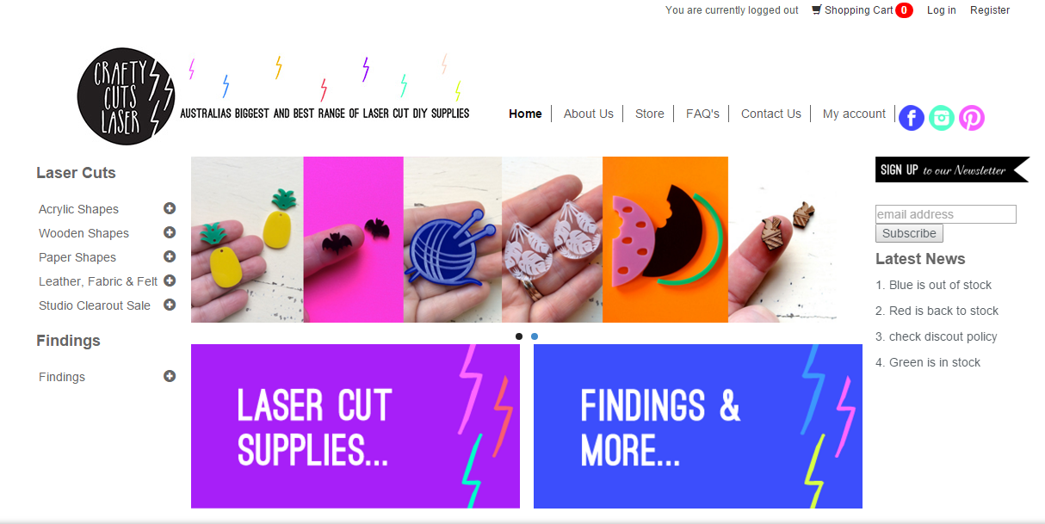

Figure 1 - Login function

The system will direct the user to enter login details when successfully accessed the website. The login page consists of a form to enter username and password. Users can fill their relevant credentials and access the Crafty Cuts Laser system.

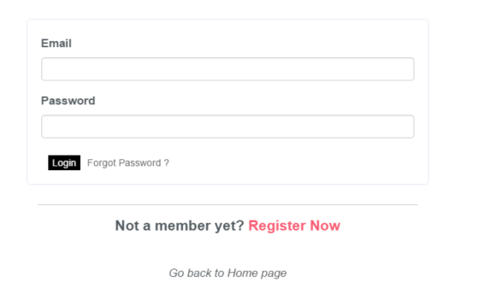

Figure 2 Login function

The above image shows the login page of the system by the administrator account. If the user provides incorrect password, an error message will be displayed and will require the user to re-enter the password.



Figure 3 Incorrect login

If the user provides correct login details, they will be redirected to the home page.

# Navigating the system

## Main navigation

The main navigation of the system is under “My Account” on the top of the home page screen. It is the main page for the administrator where they can manage items, customers and profile.

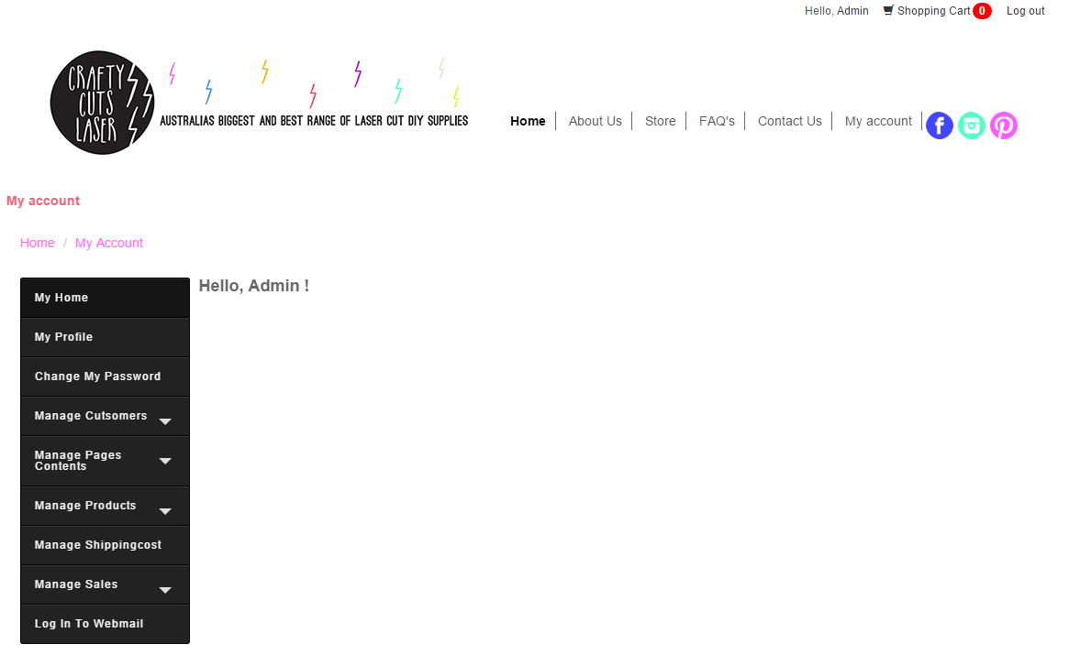

Figure 4 - My account functions

The functions displayed on the left side of the above image are the main navigation of the administrator account. An administrator can access to functions related to customers, products, news and profile.

# System Functionality

This section covers all the functionalities provided by the Crafty Cuts Laser system.

## The administrator functionalities

1. View Profile
2. Chang password
3. Manage customers
   1. View all customers
      1. View, Edit and Delete
   2. Create a new customer account
4. Manage page contents
   1. Edit page contents
      1. View
      2. Edit
   2. Edit slider images
      1. View Slider images
         1. Delete
      2. Add slider images
5. Manage products
   1. View all products
   2. Create new product
   3. Manage product colours
      1. View all colours
      2. Add new colour
   4. Manage product materials
      1. View all materials
      2. Add new materials
   5. Manage product sizes
      1. View all sizes
      2. Add new sizes
   6. Manage product finishes
      1. Add all finishes
      2. Add new finish
   7. Manage product categories
      1. View all categories
      2. Add new categories
6. Manage shipping cost
7. Manage sales
   1. View all unpaid orders
   2. View all paid orders
   3. View all completed sales
8. Log in to webmail
9. Log in and out of the system
10. Browse the store

## The customer functionalities

1. Register
2. Editing customer profile
3. Change password
4. View products
5. Browse store
6. Purchase products
   1. Add product to shopping basket
   2. Add
7. Make Inquiries “Contact Us”
8. View news
9. View about us
10. View FAQ’s
11. Logging in and out of the system

Once a user is logged in to the system, they can access to the functions of the system based on their authority level.

Administrator will be able to access all the pages and can perform all the functions of the system. While the customers will only be able to access pages that does not change the content of the system except their account profile and setting. Additionally guests will be able to view the product but will not be able to see discount information. This is shown below.

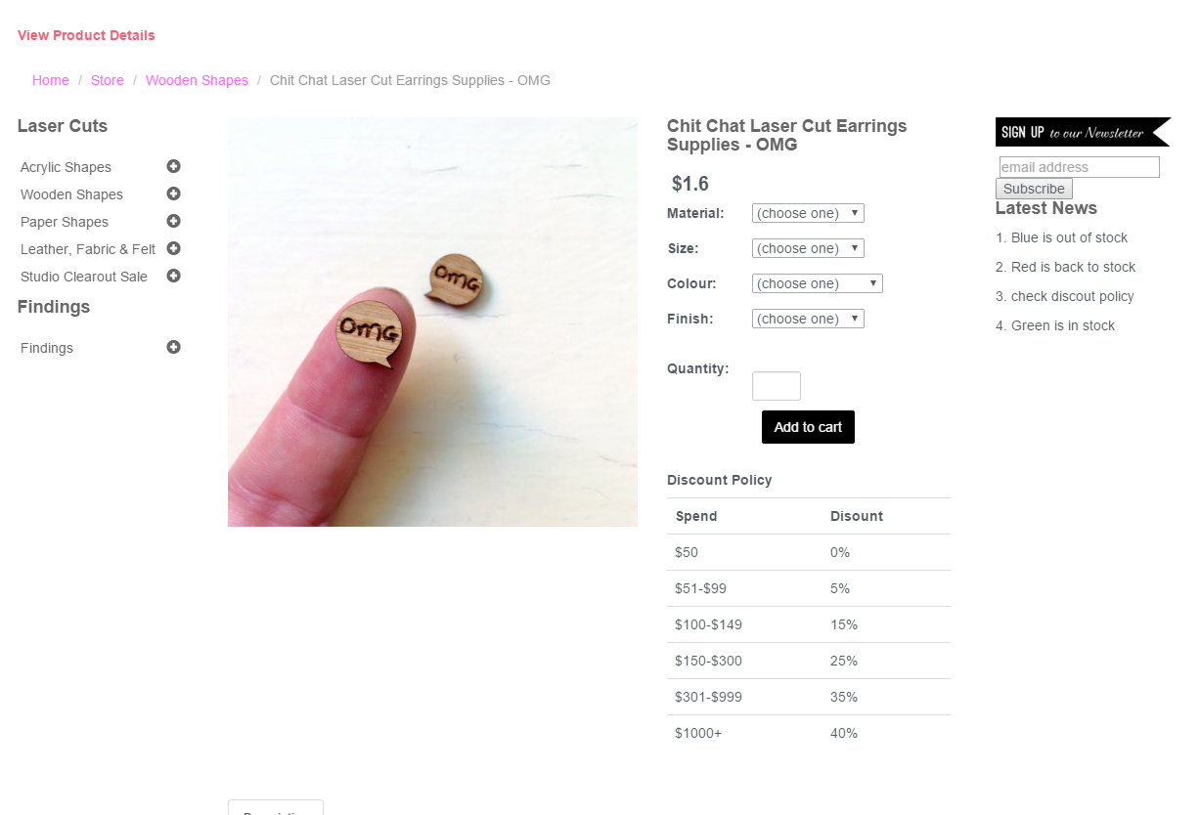

Figure 5 – View product as customer

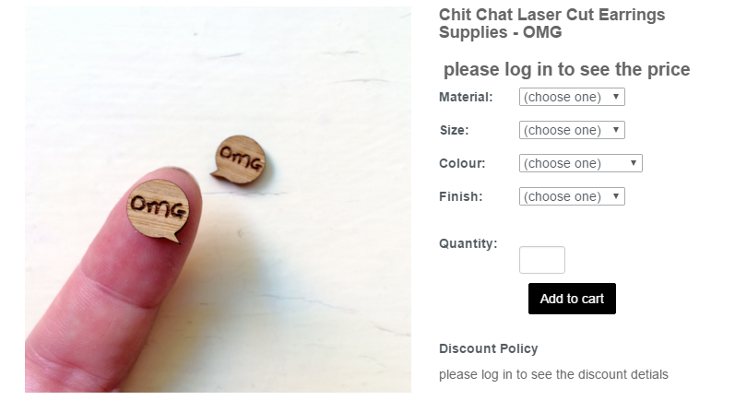

Figure 6 – View product as guest

# Administrator’s Functionalities

## View Profile

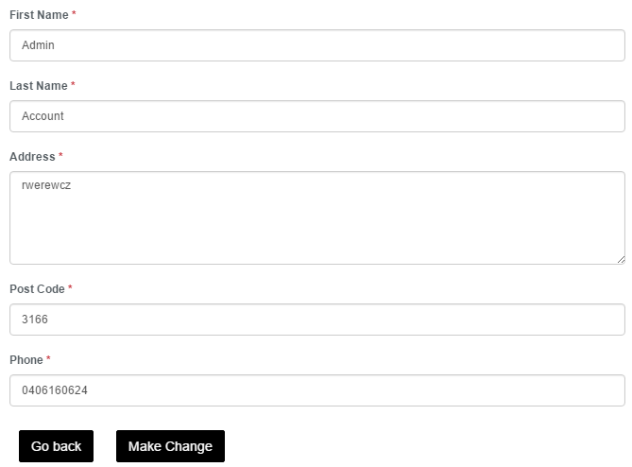

Figure 7 - Administrator’s list of products

## Change Password

Admin can change their password by clicking on “Change my password” button on the left side of the menu in My Account. From here two things can occur.

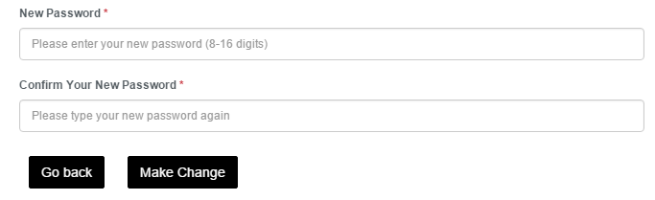

Figure 8 – Administrator change password

If the admin successfully changed the password, then the system will direct the admin to the log in page.

However, if the password is not correct or does not meet the length requirement, the system will display a message showing appropriate password length.

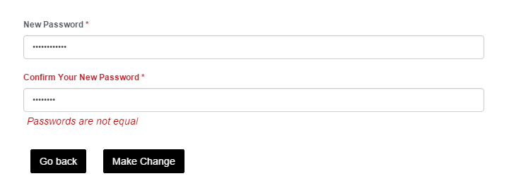

Figure 9 –Password error message

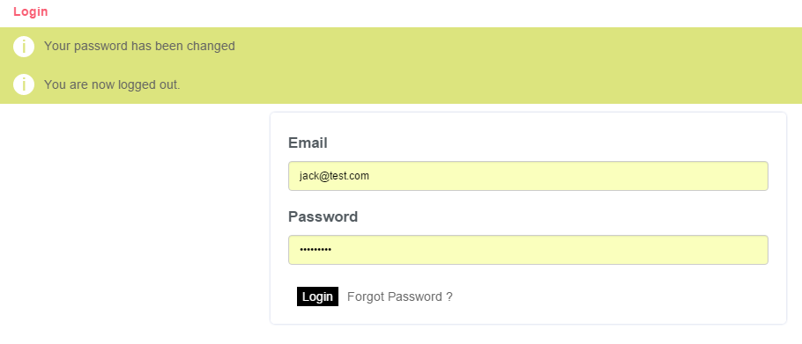

Figure 10 – Password changed message

## Manage Customers

The administrator selects the manage customers tab from the My Account menu opening up further selection options

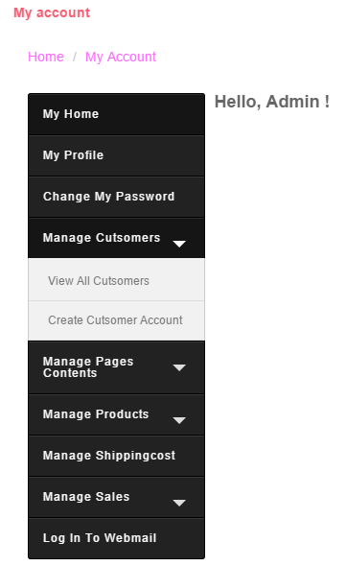

Figure 11 – Manage Customers Tab

### View All Customers

Admins are able to search for customers, order by first name, last name etc. They can search by post code or any variable they decide that matches a customer.

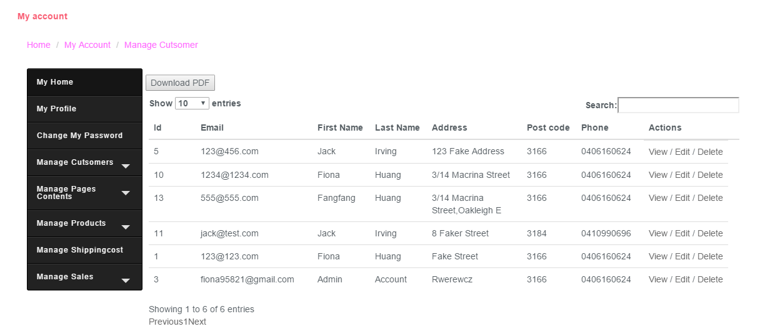

Figure 12 – View all customers

### View Customer

The admin selects View beside the desired customer’s details and is able to view their profile. As shown below.

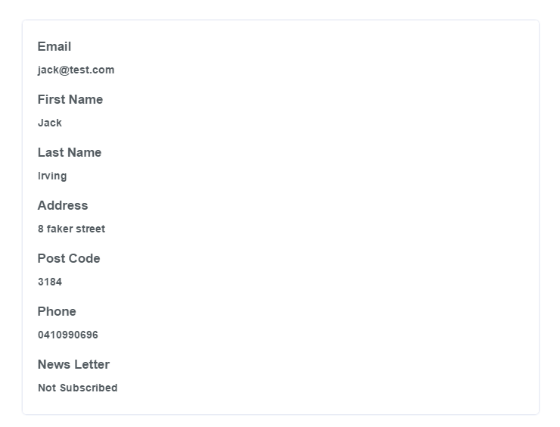

Figure 13 – View customer profile

### Edit Customer

Like view the admin selects edit which is situated beside the customers’ description and is able to edit the customer details. After a customer has been edited successfully the admin will be directed back to their My Account homepage and a message will be displayed.

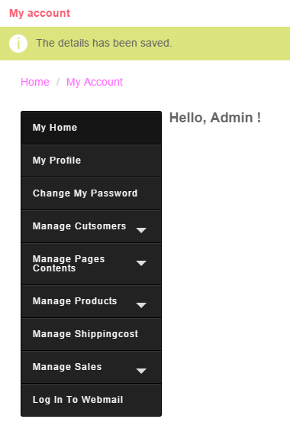

Figure 14 – Edit customer information

### Delete Customer

Click on delete, admin will be prompted to confirm the deletion of the account after which if the admin proceeds a confirmation message will show confirming the action.

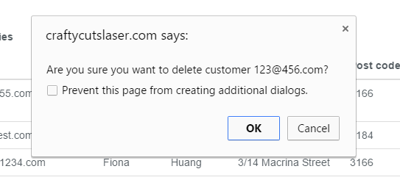

Figure 15 – Delete customer confirmation request

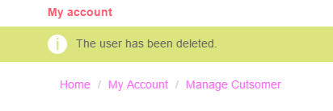

Figure 16 – Delete customer confirmation message

### Download PDF

Press the download PDF button top left of the view all customer table and it will download a pdf which can be opened and will show the below content.

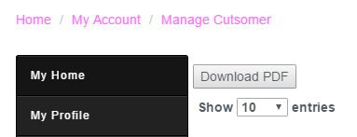

Figure 17 – Download PDF

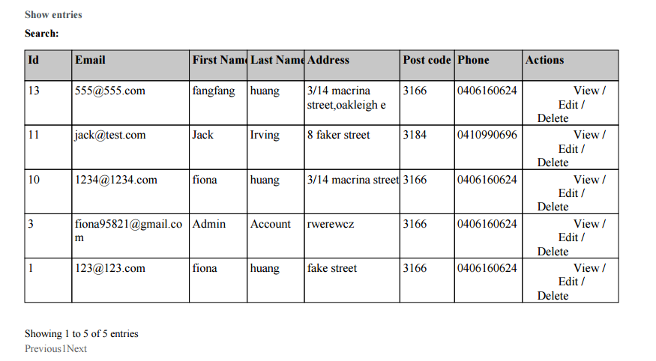

Figure 18 – View PDF

### Register new Customer

In order for the Admin to register a new customer they first must click on “Create Customer Account” which will redirect the admin to fill out the form shown below.

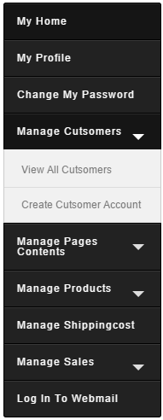

Figure 19 – Create Customer Account

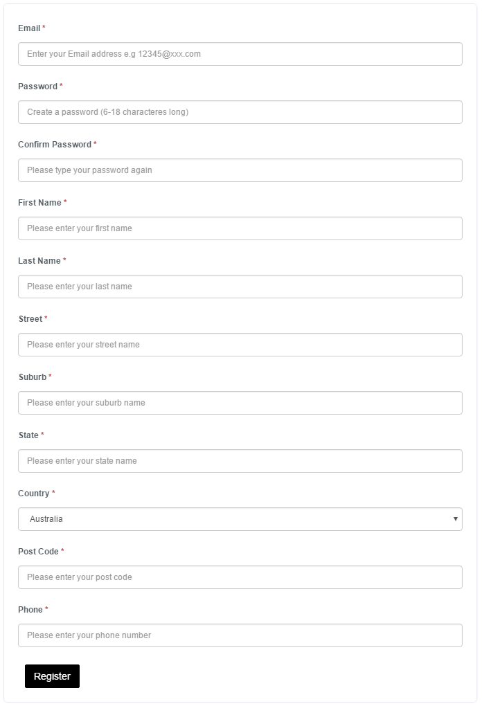

Figure 19 – Create Customer Account Form

## Manage Page Contents

### Edit Page Contents

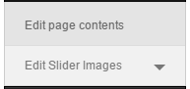

Figure 20 – Edit Page Contents tab

From the edit page contents tab, the admin is able to select any of the editable pages (as shown below). The pages which are currently created are the FAQ’s, About us, News, Privacy Policy, Terms and Conditions and the Postage, Payments and Returns section.

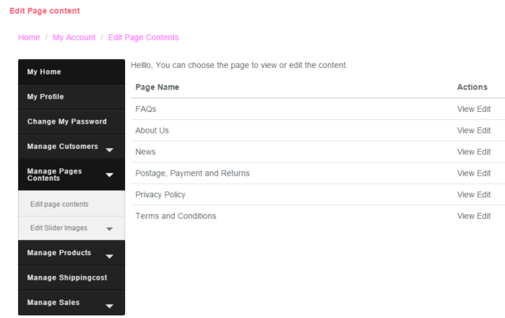

Figure 21 – Edit Page Contents options

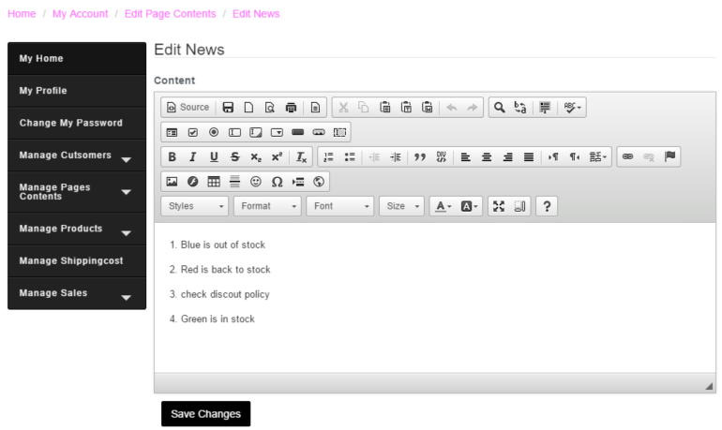

Figure 22 – Edit news with text editor

As shown above, the user is able to utilise a wide variety of text editor tools, which will allow for formatted news posts. Below is an example of how the FAQ page is handled. It is split up into sections, additional sections can be added as they are needed. Sections can be viewed, edited and deleted via the right hand menu.

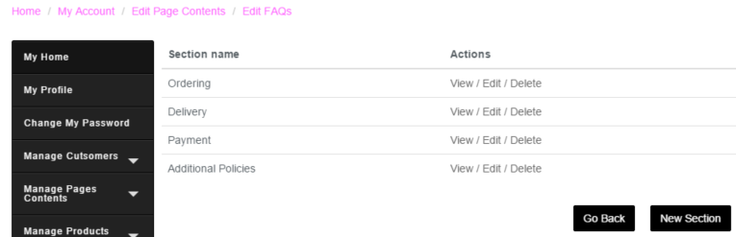

Figure 23 – Edit FAQ’s

## Edit Slider Images

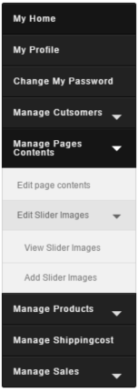

Figure 24 – View slider images

### View slider images

The images for the slider will be displayed one above another with the options of deleting them via the right hand side under the section titled “actions”.

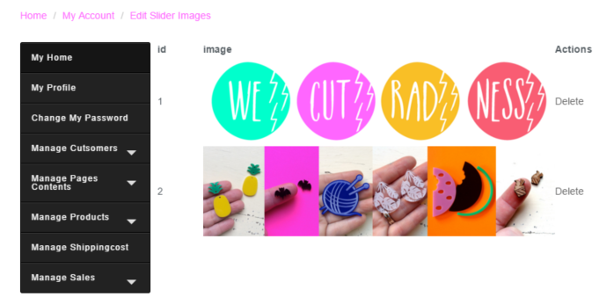

Figure 25 – View slider images

### Add slider images

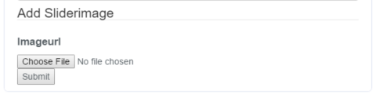

Figure 26 – Add slider image

In order to add a new image, first the admin should click on Choose File and then select the desired image, press open and then click submit to confirm the image for the image slider. After the user presses submit a confirmation message is presented.

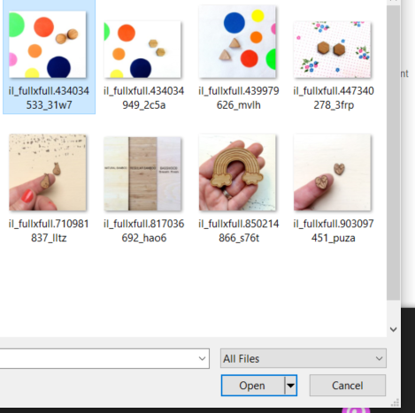

Figure 27 – Select image for image slider

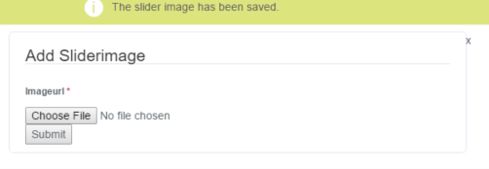

Figure 28 – Slider image confirmation

## Manage Products

### View all product

The below picture is the administrator page of all products currently in the system. The administrator can hide a particular product when it is running out of stock, so that customers will no longer be able to view the hidden products or make purchases. The administrator may also search for a specific product via the top right hand side of the page.

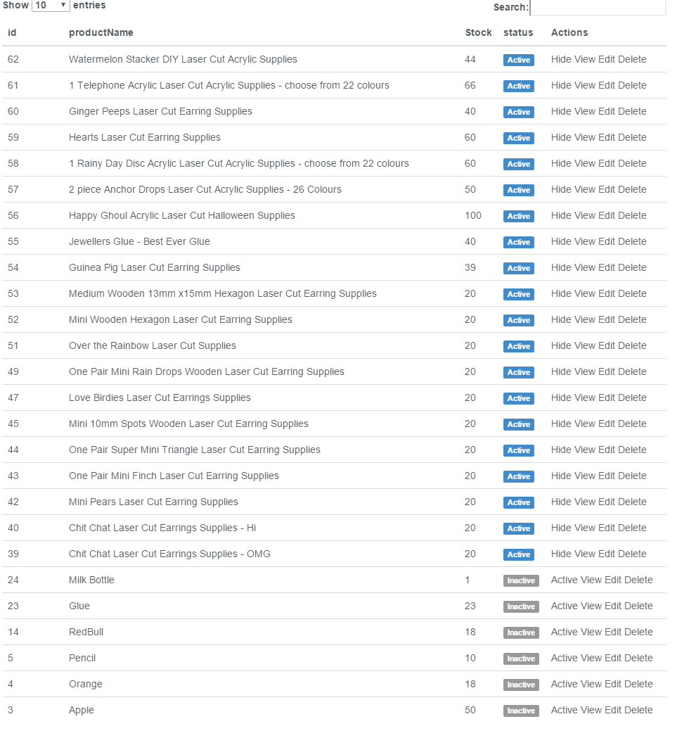

Figure 29 – View all products

Via the right hand side of the page the administrator can view, edit and delete a product. When a product is Active its highlighted blue with an active sign in the “status” section. When it is inactive it is greyed out with inactive showing in the “status” section.

### Create new product

New product is selected via the menu and is found under Manage Products, as shown below. From there, the user needs to select New Product and then proceed to creating a product by filling out the form.

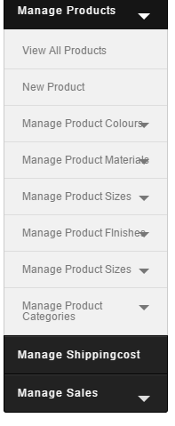

Figure 30– View all products

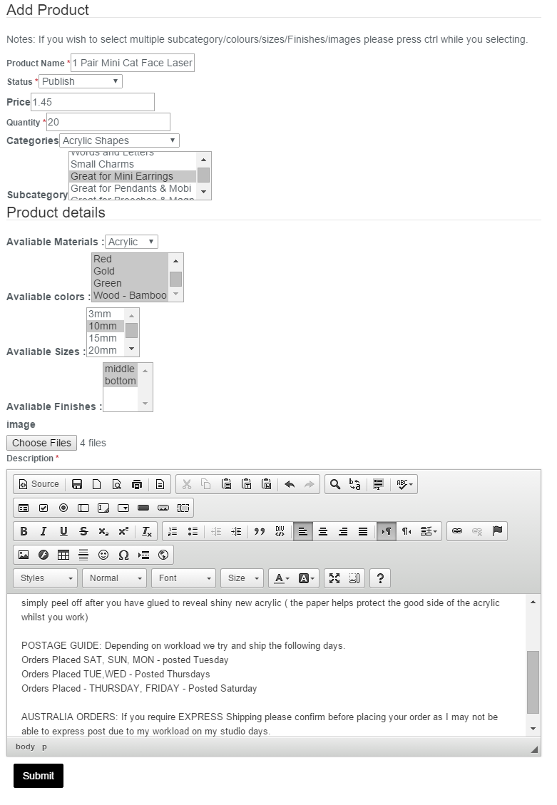

Figure 31– Add new product form

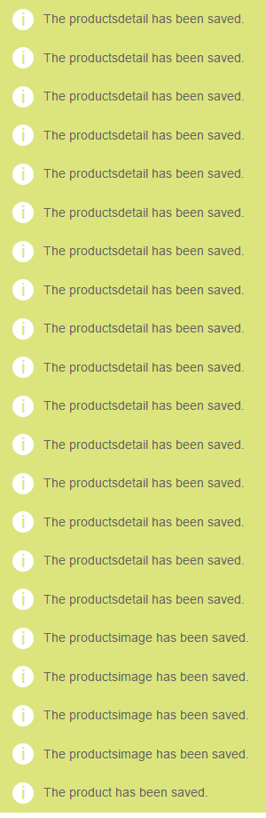

Figure 32– Add new product confirmation message

### Manage product colours

Viewing colours and adding colours are very straight forward. A colour has a description (name) and potentially an extra cost associated to it. As shown below, the new colour is to be called Gunmetal grey and is will have an additional cost of $1.

In the figure just below, colours can be set to out of stock and in stock. Like the active and inactive item management system. If a colour is in stock it’s status is shown in blue, if it is out of stock it’s status is displayed in grey.

#### View all colours

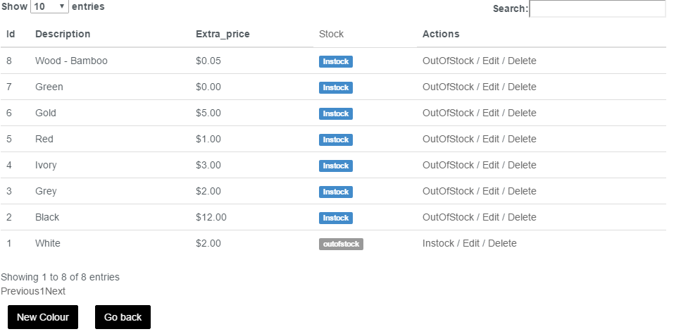

Figure 33– Add new product confirmation message

#### Add new colour

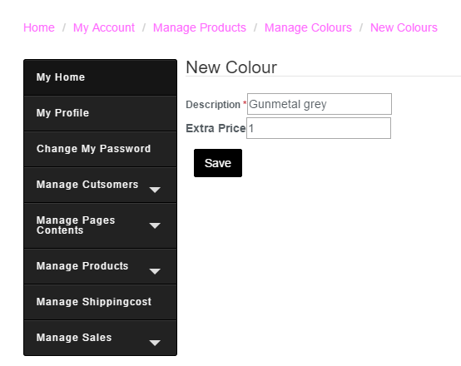

Figure 34– Add new product confirmation message

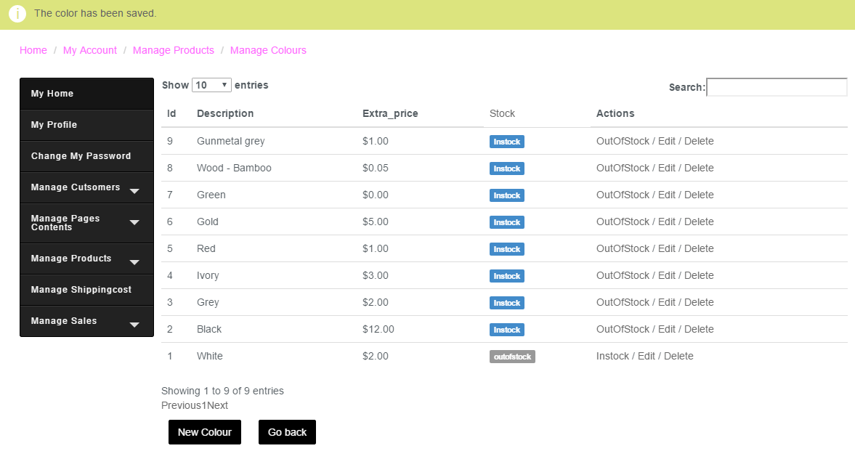

Figure 35– Add new product confirmation message

## Manage product materials

In order to manage materials the admin first needs to click on Manage products and then go to manage product materials. From there the admin can select to view all materials or add a new material. From the all materials page, the admin can add a new material also.

### View all materials

From the view all materials page, the admin can edit or delete any material available. Below are screen shots of adding a material, the confirmation message that follows successfully adding a new material and finally the message after successfully removing a material.

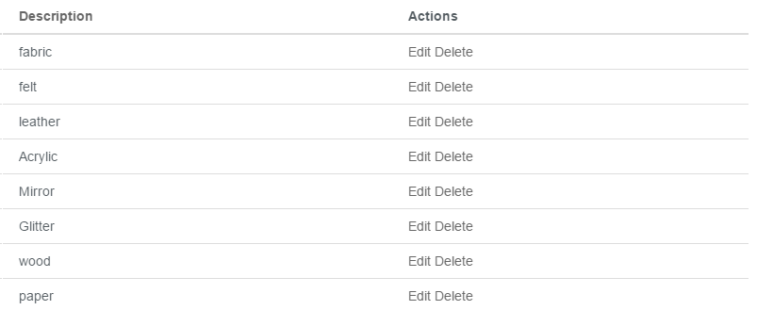

Figure 36– Add new product confirmation message

### Add new material

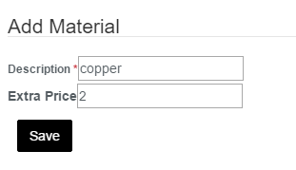

Figure 37 – Add new material

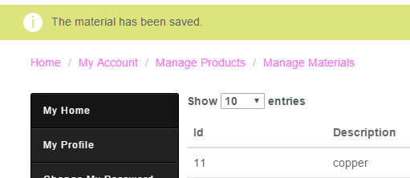

Figure 38 – Add material message

### Delete material

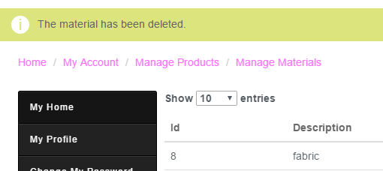

Figure 39– Delete material message

## Manage sizes

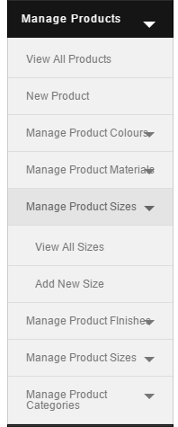Managing sizes can be accessed from admin menu and clicking on Manage Product Sizes. From here, the admin can view all the sizes or add a new size. From the view all sizes tab, edit and delete become available. Below are

### View all sizes

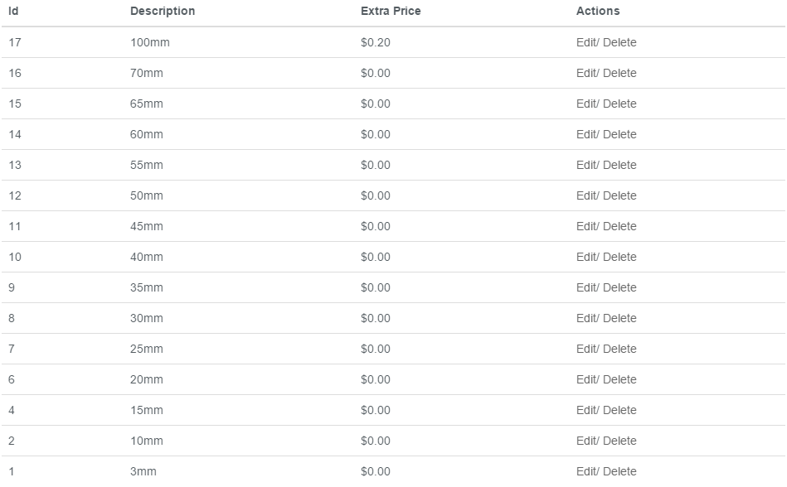

Figure 40– View all sizes

### Add size

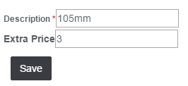

Figure 41– Add new size

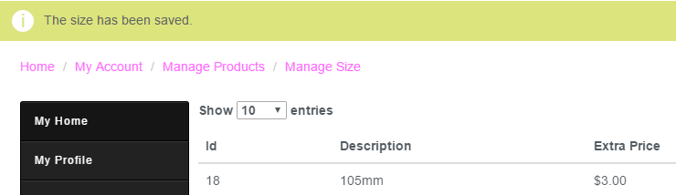

Figure 42– Add new size confirmation message

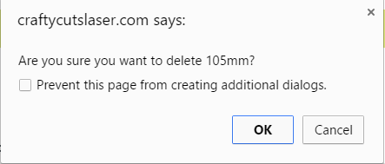

Figure 43– delete size confirmation box

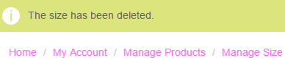

Figure 44– delete size confirmation message

## Manage finishes

After selecting Manage products, the admin then navigates to manage product finishes. From here they may make two selections, to view all finishes and to add all finishes.

### View all finishes

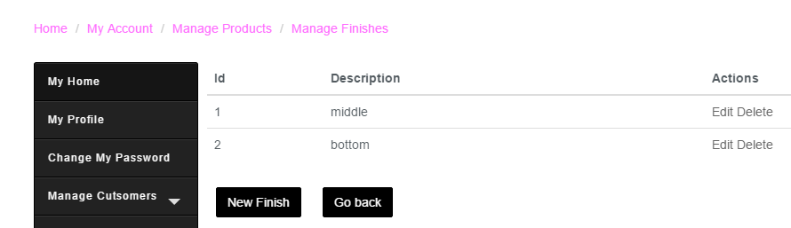

Figure 45– View all finishes

### Add new finishes

The admin can either use, the button below the finishes table or may make a selection from the admin menu. From here all the admin needs to do is input a description of the finish and that’s it. Like so.

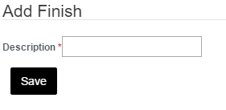

Figure 46– Add new finish

## Manage product categories

### View all categories

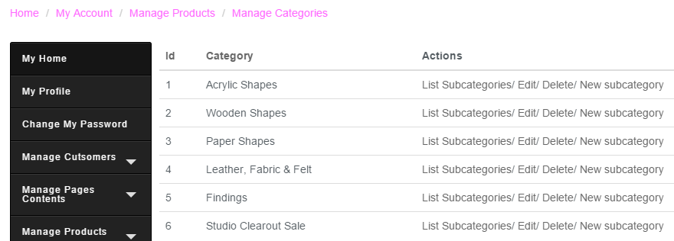

Figure 47– View all categories

#### Add new subcategories

In order to add a new sub category, first the admin must go to the categories page, from here they can select to add a new subcategory. First the admin inputs the desired name and then the category which it’ll be linked too.

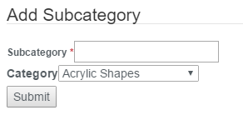

Figure 48– Add sub category

### Add new category

The admin first selects Manage products, from there they click on manage categories followed by add new categories. Here the admin may enter in a category name and an as detailed description as they like. Shown below is the full text editor options for the description.

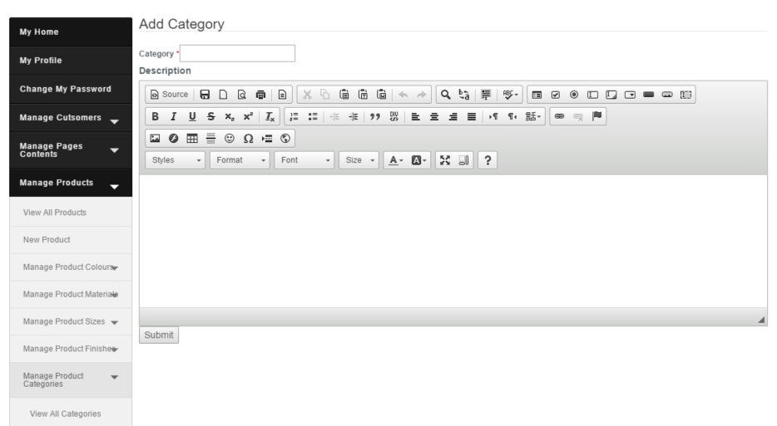

Figure 49– Add Category

## Manage Shipping Costs

Shipping costs are very straight forward. There are some pre-set shipping costs which can be edited as the admin sees fit. They are in the format of Amount from to Amount To. In order to change this click on edit.

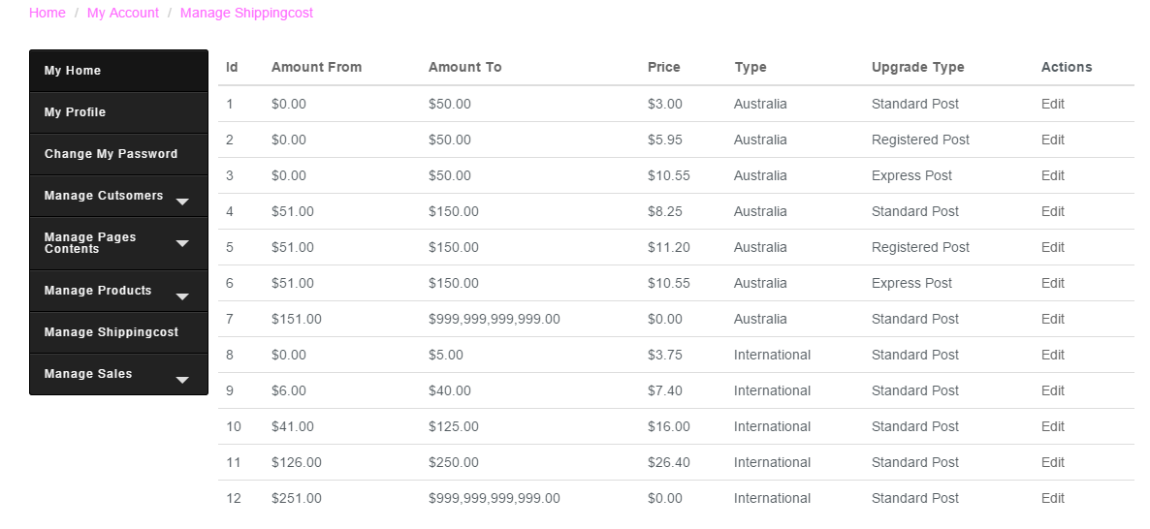

Figure 50– Manage shipping costs

Below is shown how to edit the shipping cost of the amounts 0-50. The cost can be updated to reflect more expensive postage costs.

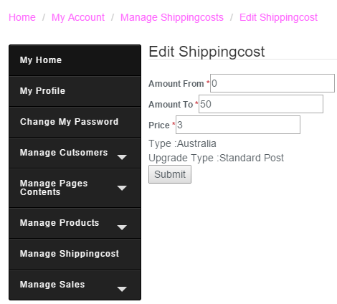

Figure 51– Edit Shipping Cost

# Manage Sales

Managing sales is done via the admin menu. When clicked there are three options. First option is View all unpaid orders, the second options is view all paid order and finally view all completed orders. Each of these are the different stages an order goes through. Once an order is paid for it is shipped and considered a completed sale.

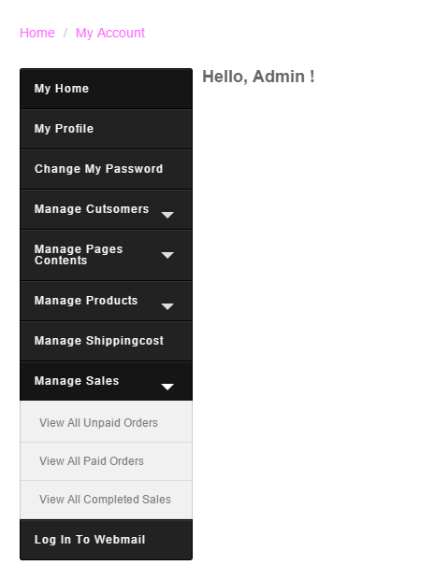

Figure 52– Manage sales menu

## View all unpaid orders

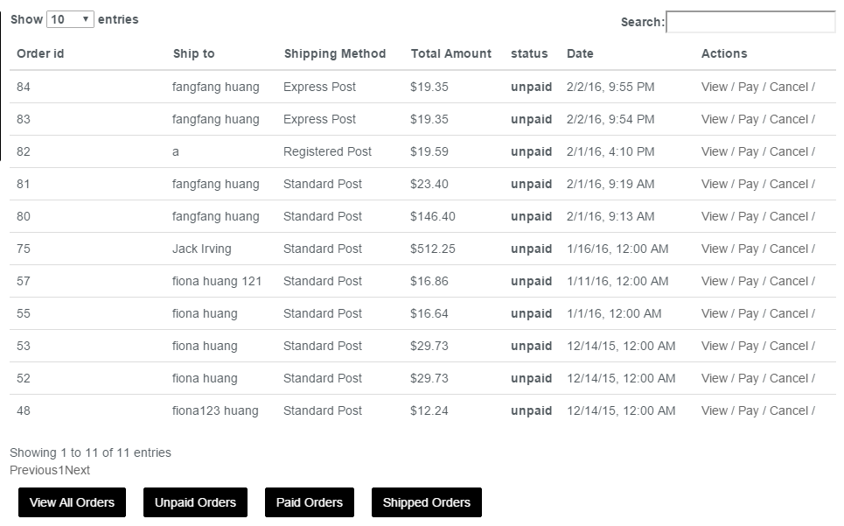

Figure 53 – Unpaid sales

## View all paid orders

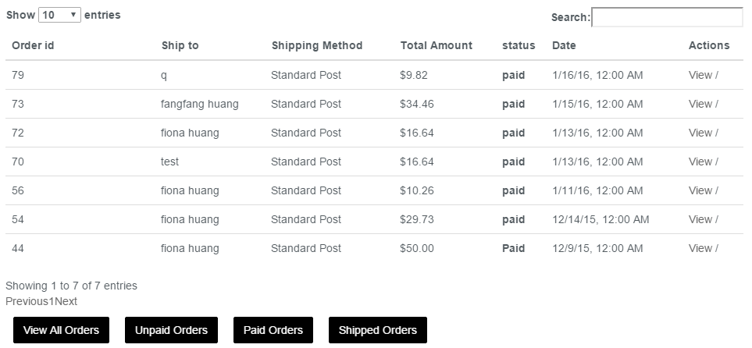

Figure 54– View paid sales

## View all completed sales

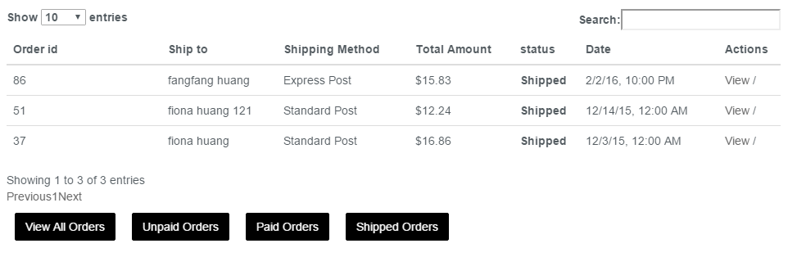

Figure 55– View all completed sales

# Webmail

In order to log into webmail, the admin first clicks on their “My account” button in the top right hand side of the screen. From here they are directed to the Admin Menu. Shown below the Webmail button is the last button. When pressed, another page will be opened and display a log in screen. Enter the desired log in credentials, these can be found in the Initial Access Instructions document but may have been changed. Once logged in to their email account the admin can select which email program they’d like to use or can even set a default. For this example roundcube is being used.

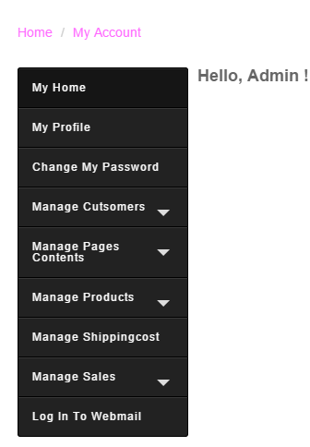

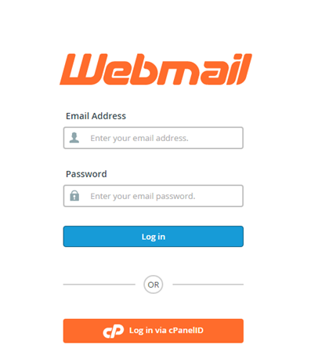

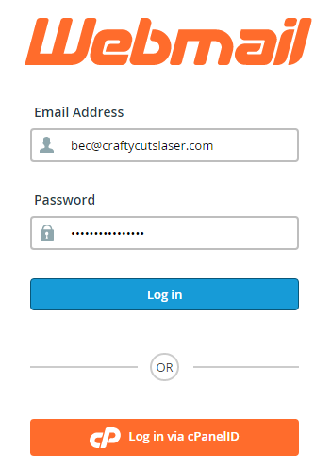

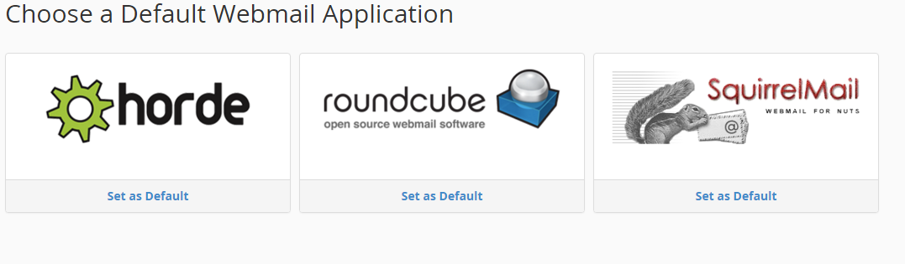

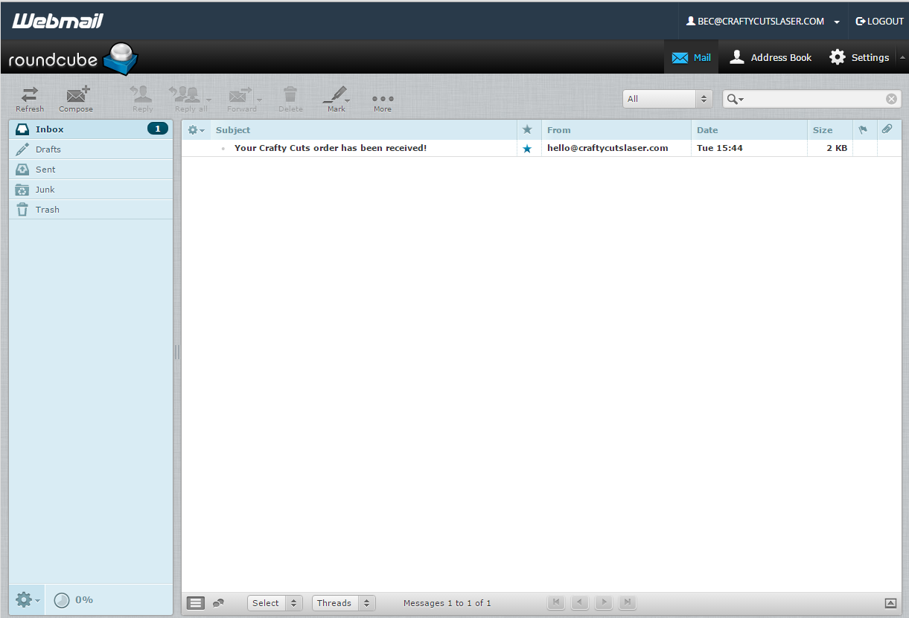

# Login and Logging out

The admin presses on the log in button from the home page or any page on the website. They enter their credentials and if successful are redirected back to the homepage. If successful no error message will show up and the message at the top of the screen will great you. The final image is an example of an incorrect log in sequence.

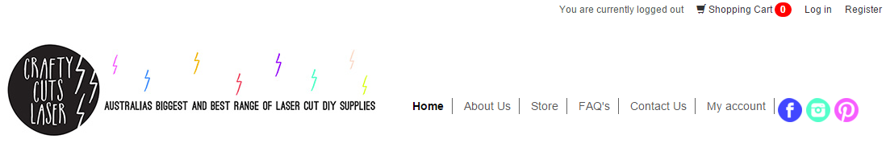

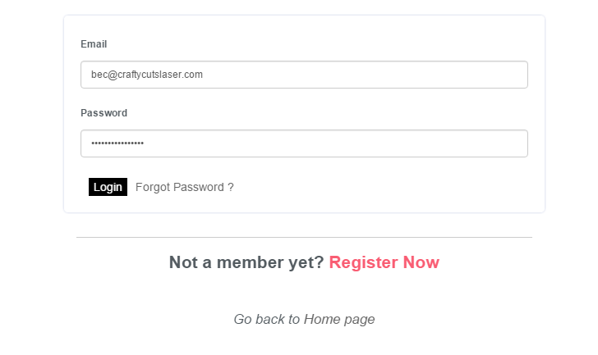

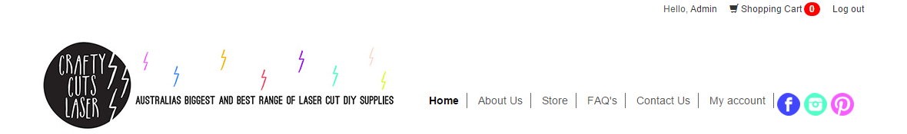



# Backups and restores

First the admin must go to the hoopla (hosting company) website as shown in the first image below. As of the time of writing this document that’s Hoopla found at <https://www.hooplahosting.com/>. Then click on the Client Area button in the top right hand corner of the site. The admin will be prompted for their log in credentials, these were provided to the client via an email by Hoopla and can be found in the Initial System Access Instructions document.

Once logged in the admin, navigates to their services, clicking on the listing and not the link to the website. From here they can select Login to CPanel, they won’t require log in credentials here however if they’ve timed out they’ll need to log in again. The login credentials specifically for Crafty Cuts Laser CPanel is provided in the initial system access documentation.

From the CPanel the admin scrolls toward the bottom of the page and selects something called Softulous App Installer. From here they are able to select Backups and Restores from the menu in the top right hand corner and are then presented with options to restore or create a new backup.

Backups are dated by the date they were created and will continue for 10 days of automated backups before the oldest is written over by a new backup. In the event that something has malfunctioned and the system needs to be restored. Pressing the blue button will restore the system to that save.

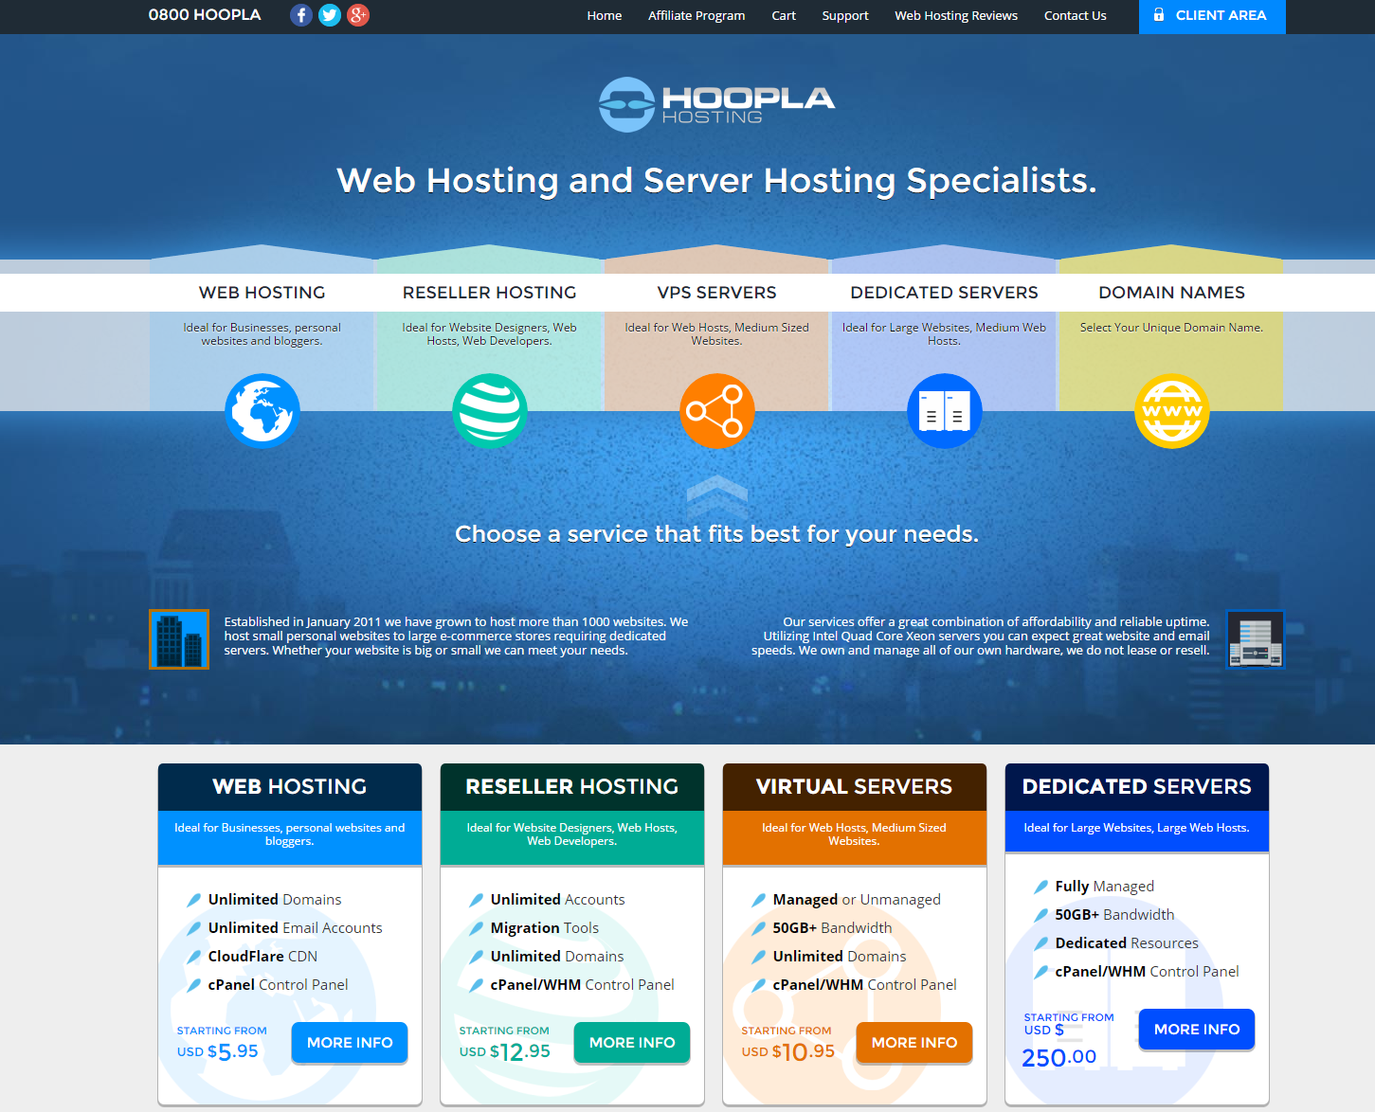

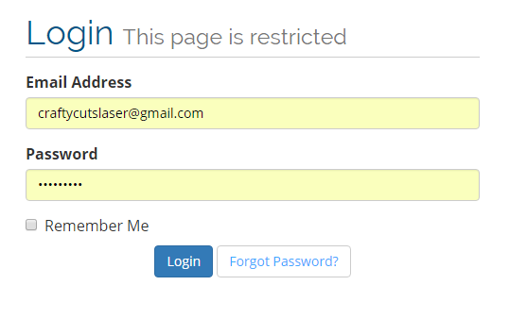

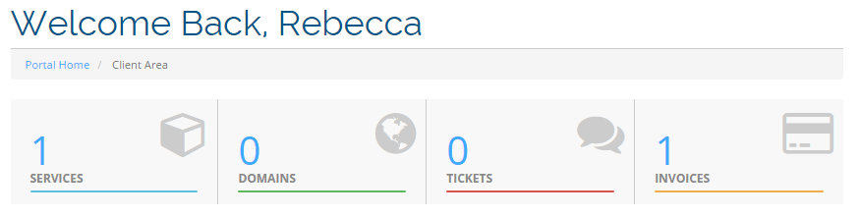

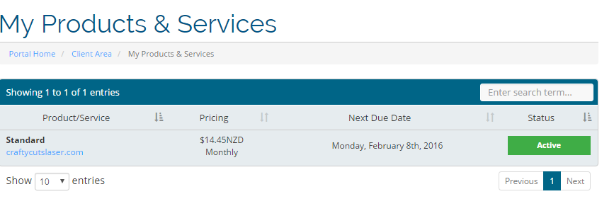

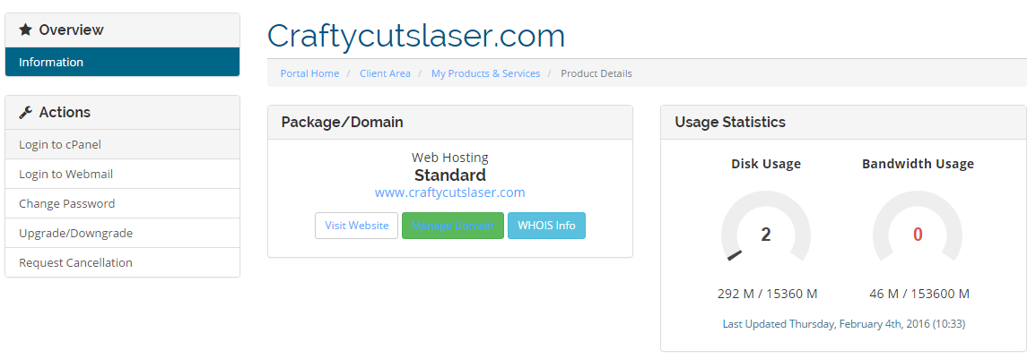

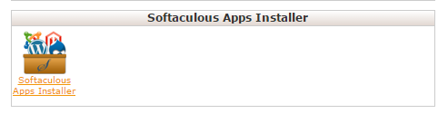

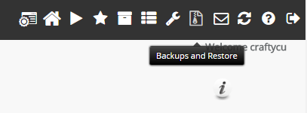

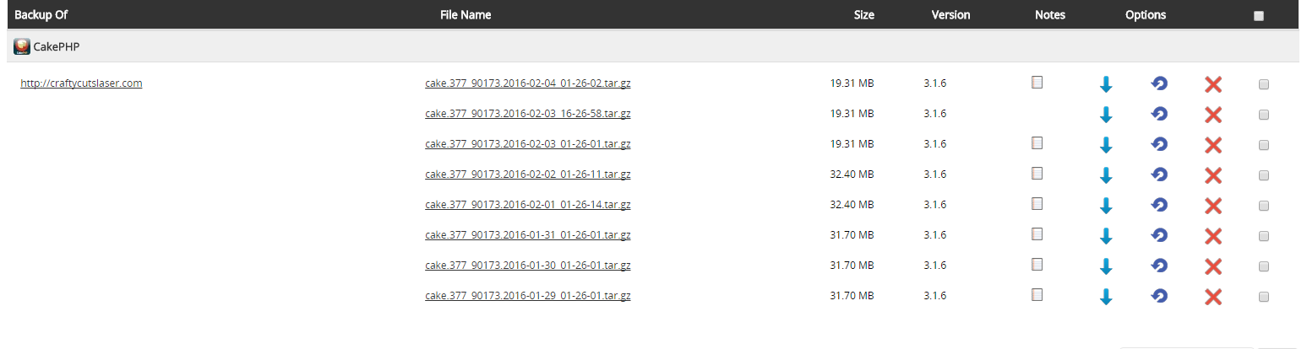

# Customer Functions

## Registration

A potential customer can register to Crafty Cuts Laser website by clicking on “Register” button in the top right of the home page. The following form will be displayed.

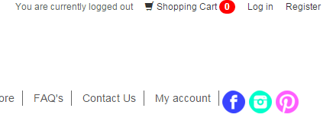

**Figure 56– Customer Registration**

When clicking on “Register” button, the system will notify the customer that the changes have been saved. Then the system will redirected the registered customer to “Login” page.

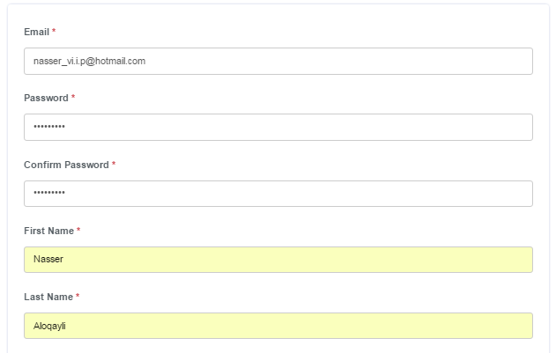

**Figure 57– Rigestration form**

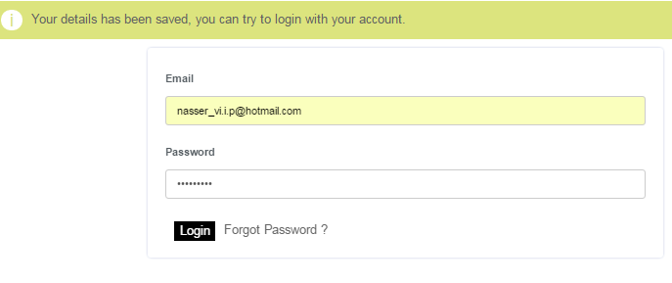

**Figure 58– Rigestration completed**

When the customer attempts to login with wrong email address or wrong password, the system will notify with the following massage:



**Figure 59– Incorrect Login**

And then, it will require the user to enter them again. If the login is successfully performed, then the system will direct the customer to the home page with welcoming message next to his/her name in the top of the home page.

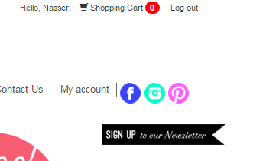

**Figure 60 – Homepage**

## View/Edit Profile

Customer can view/edit profile details by clicking on “View/Edit my profile” under “My account” button in the home page.

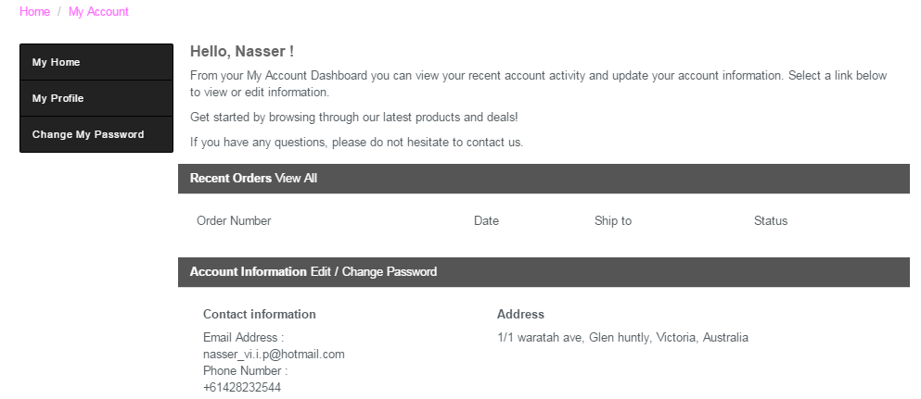

**Figure 61 – Customer’s Account**

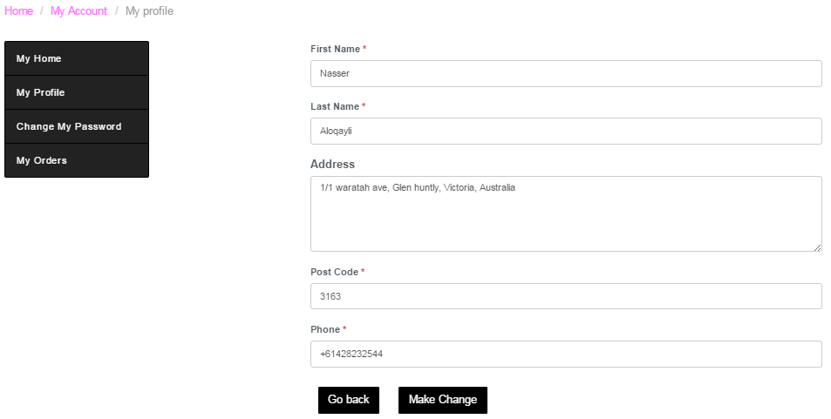

**Figure 62 – Customer’s Profile**

The customer can click on “Go back” button if they want to go back and not proceeding in changing their profile. Or, click on “Make Change” to update their profile as they want.

## Customer Change Password

The customer can change his/her account password by clicking on “Change my password” button, and the system will direct them to the following form:

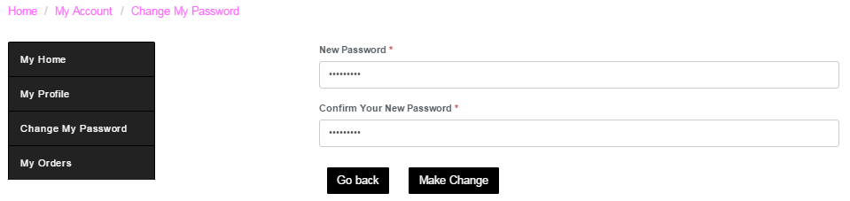

**Figure 63 – Customer’s Change Password**

The customer can click on “Go back” button if they want to go back and not proceeding in changing their password.

Also, when they click on “Make Change” button after they enter their new password, the system will direct them to login page and notifies the customer that they are logged out.

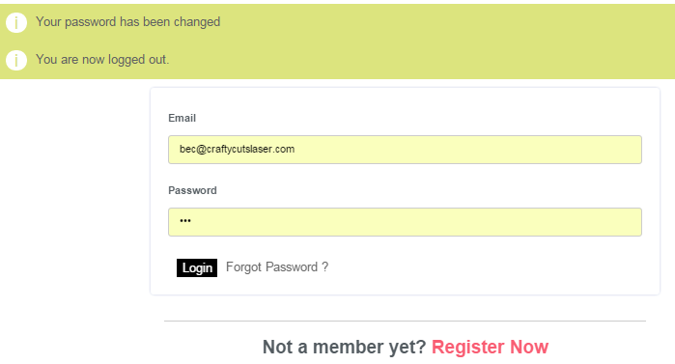

**Figure 64 – Customer’s Changed Password**

However, if the password is not correct or does not meet the length requirement, the system will display a message showing appropriate password length.

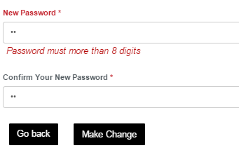

**Figure 65 – password error message**

## Customer Contact the Admin

The customer can contact with the administrators or make inquiries by clicking on “Contact Us” on the top bar of the home page. The following form is displayed:

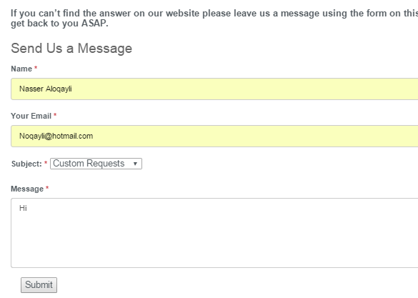

**Figure 66 – Contact Us form**

By clicking on “Submit” button, the system will notify the customer that the enquiry has been sent.



**Figure 67 – Contact Admin is Made**

## Customer View Company’s Details

The customer can view the company’s details by clicking on “About Us”.



**Figure 68 – About us**

## Customer View Products

The customer can view available products by clicking on “Store” on the top bar of the home page.

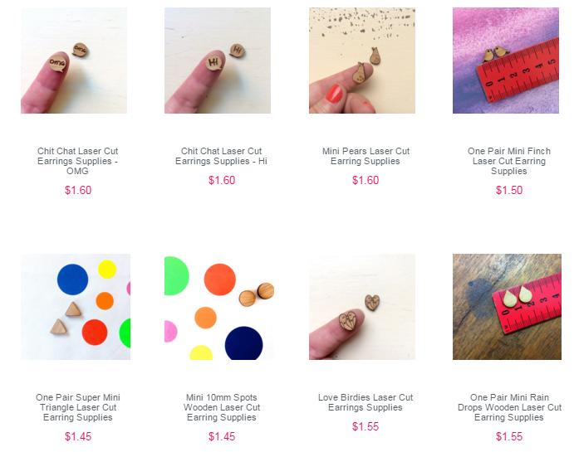

**Figure 69 – Products in the website**

If the customer would like to view further details about any product, they can click on the product which will direct them to view product details.

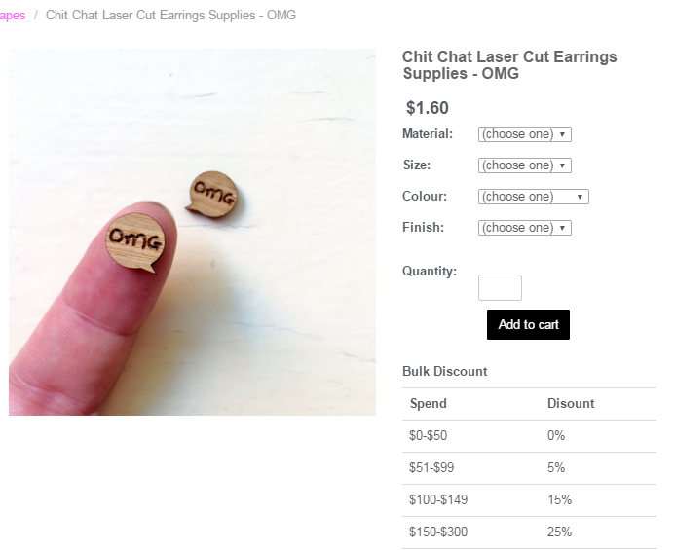

**Figure 70 – Products’ details**

## Customer Filter Categories

The customers of the website can also filter the products as they want. From the bar on the left side of the homepage, they can choose particular products’ categories to look for.

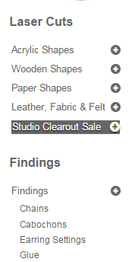

**Figure 71 – Products’ categories**

By clicking on Acrylic Shapes and then clicking on Cats and Dogs, the system will filter the products and display products in this categories.

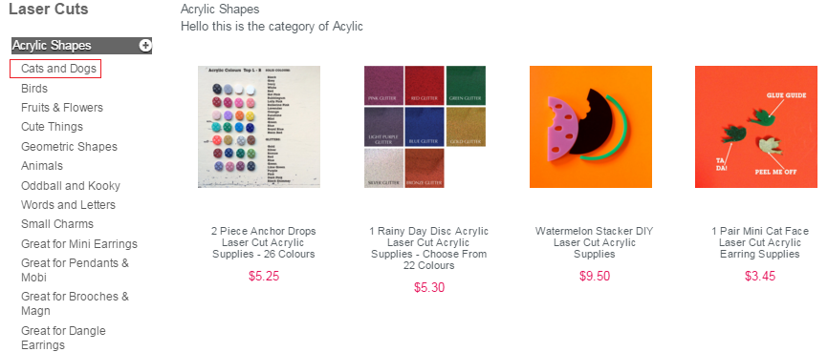

**Figure 72 – Products’ categories**

## Customer Purchase Order

When the customer clicks on the picture of the product, they will be directed to the following form:

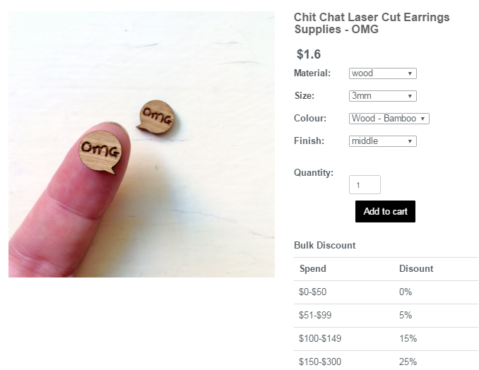

**Figure 73 – Products’ details**

After choosing the material, size, colour, finish and quantity, they can click on “Add to cart” button. The system will notify the customer that the product has been saved in the cart as shown below.



**Figure 74 – Products Purchased**

However, if the customer did not choose anyone of the displayed features or typed inappropriate number in the quantity field, the system will display the following message.

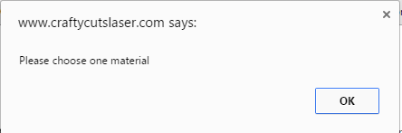

**Figure 75 – Products Purchased Error Message**

If the customers click on “Shopping cart” button, the system will show all the details of their shopping cart.

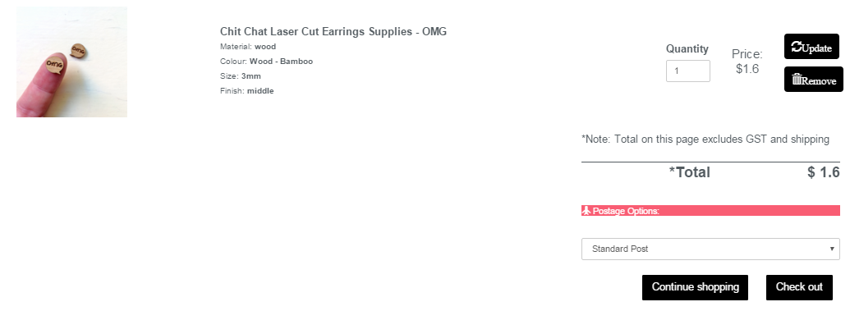

**Figure 76 – Shopping cart**

The customers will be able to update the quantity of their products or remove the product from the shopping cart. Then, the customer will select the shipping method from the drop down box next to the total price.

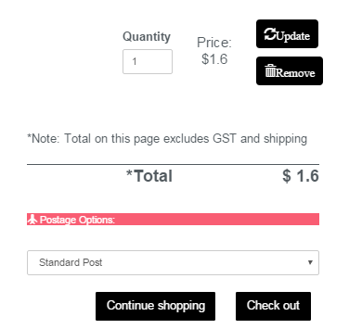

**Figure 77 – Shipping Method and Checkout**

When the customers click on “CHECK OUT” button, they will be directed to confirm their order by filling the following form:

When customers fill all the details and click on “Payment” button, their order will be saved and they will be directed to the order page to check out.

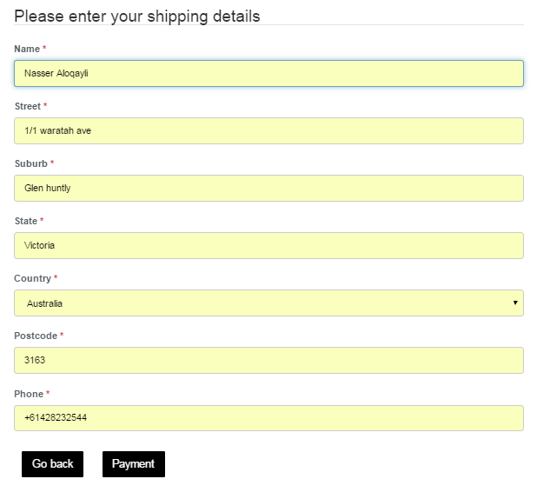

**Figure 78 – Personal Details**

When customers fill all the details and click on “Payment” button, their order will be saved and they will be directed to the order page to check out.



**Figure 79 – Order is Saved**

If there were inappropriate inputs such as inappropriate name, street, suburb state or even negative numbers, empty fields or inappropriate inputs in the fields where numbers supposed to be, the system will notify the customer by showing the following message:

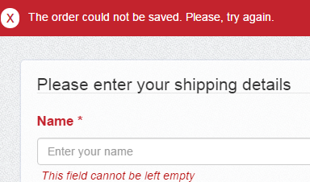

**Figure 80 – error message**

By clicking on “PayPal Check out” button, customers will be directed to the PayPal page to make the payment.

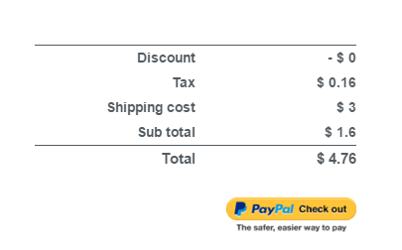

**Figure 81 – Paypal link**

This is the page where the customers make their payment. It is PayPal payment method where the customers make the payment and receive receipt.

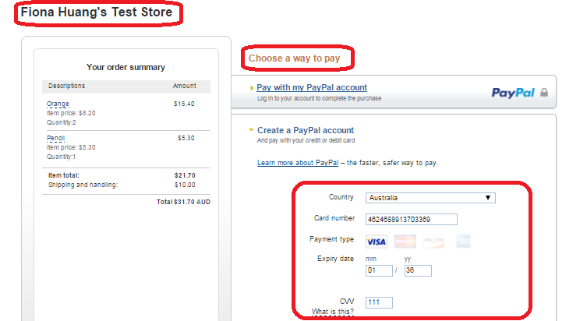

**Figure 81 – Paypal payment**

After the payment is made, then the customer will be directed to the website.

# Password Recovery

In this section, the “Password Recovery” functionality will be covered.

If for some reason a user, whether it is an administrator or customer, forgets their password to login to the system, they can recover it using the “Password Recovery” functionality.

The way this functionality works is by using the email registered in the “Users” entity.

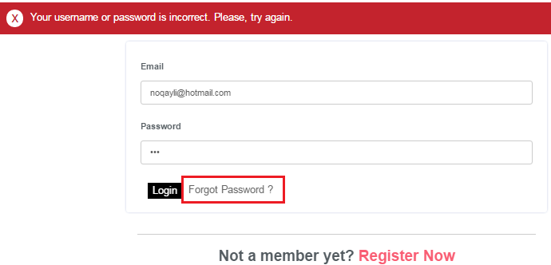

**Figure 83 – Login Failed**

The password is then reset into a random string and sent to the users email account, like with any other password recovery system. The user can then use that temporary password to login to the system and change their password by using the “Change my password” link under “My account” page.

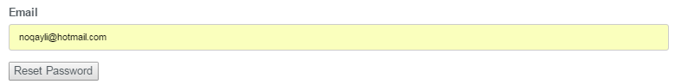

**Figure 84 – Reset Password**

After the user entered his/her email address, the system will check the validity of the email address. If the email address is registered in the system, the system will send password recovery email displaying the steps to reset the password, and it will notify the user that the password recovery step is sent.



**Figure 85 – Reset Password is sent**

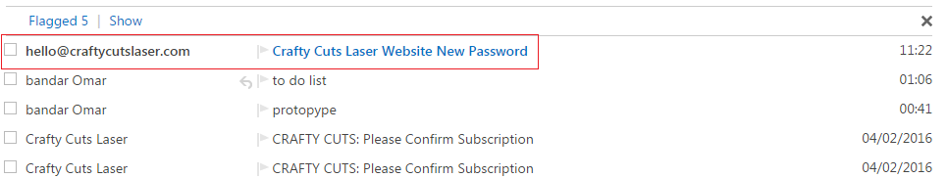

**Figure 86 – User’s email**

When the users receive the recovery email from the system, they can then click on the link to reset their password.

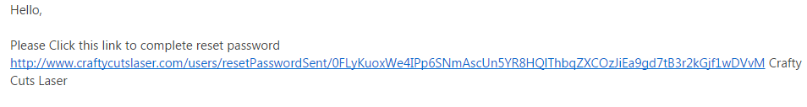

**Figure 87 – Recovery Link**

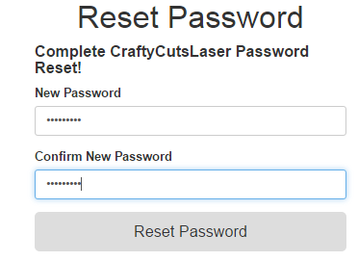

**Figure 88 – New Password**

Then the user can enter the new password and click on Reset Password. The system will direct the user to the login page. And notify the user that the password has been changed.